
National University of Technology

Machine Learning Lab- CS3504

LAB Submitted to:

Lec.Hajra Ahmad

Submitted By:
Muhammad Abdullah

Reg. No: F22607010
Batch: Fall AI 2022
Lab : 10
Q.NO.1:
- Real Time CLustring.
Answer:

import numpy as np
import matplotlib.pyplot as plt
from sklearn.datasets import make_blobs
from collections import deque

# Constants for K-Means
K = 3 # Number of clusters
MAX_ITER = 10 # Maximum number of iterations for centroid update
DISTANCE_THRESHOLD = 2.0 # Outlier detection threshold
CONCEPT_DRIFT_THRESHOLD = 0.1 # Threshold to detect concept drift

# Function to calculate Euclidean distance
def euclidean_distance(point1, point2):
return np.sqrt(np.sum((point1 - point2) ** 2))

# Class to manage the K-Means clustering
class RealTimeKMeans:
def __init__(self, k, max_iter=10):
self.k = k
self.max_iter = max_iter
self.centroids = None
self.cluster_stats = {} # To track cluster count, mean, and variance

def initialize_centroids(self, data_points):
"""Initialize centroids by selecting random points from data"""
random_indices = np.random.choice(len(data_points), self.k, replace=False)
self.centroids = data_points[random_indices]

def assign_points_to_centroids(self, data_points):
"""Assign each point to the nearest centroid"""
cluster_assignments = []
for point in data_points:
distances = [euclidean_distance(point, centroid) for centroid in self.centroids]
cluster_assignments.append(np.argmin(distances))
return cluster_assignments

def update_centroids(self, data_points, cluster_assignments):
"""Update centroids by calculating the mean of assigned points"""
new_centroids = np.zeros_like(self.centroids)
for i in range(self.k):
assigned_points = [data_points[j] for j in range(len(data_points)) if cluster_assignments[j] == i]
if assigned_points:
new_centroids[i] = np.mean(assigned_points, axis=0)
return new_centroids

def update_cluster_stats(self, data_points, cluster_assignments):
"""Update cluster statistics: count, mean, and variance"""
for i in range(self.k):
assigned_points = [data_points[j] for j in range(len(data_points)) if cluster_assignments[j] == i]
if assigned_points:
count = len(assigned_points)
mean = np.mean(assigned_points, axis=0)
variance = np.var(assigned_points, axis=0)
self.cluster_stats[i] = {'count': count, 'mean': mean, 'variance': variance}

def detect_outliers(self, data_points, cluster_assignments):
"""Identify outliers based on the distance threshold"""
outliers = []
for i, point in enumerate(data_points):
cluster_id = cluster_assignments[i]
centroid = self.centroids[cluster_id]
distance = euclidean_distance(point, centroid)
if distance > DISTANCE_THRESHOLD:
outliers.append(i)
return outliers

def detect_concept_drift(self, old_centroids):
"""Detect concept drift by comparing centroids"""
if self.centroids is None or old_centroids is None:
return False
drift_detected = False
for i in range(self.k):
if euclidean_distance(self.centroids[i], old_centroids[i]) > CONCEPT_DRIFT_THRESHOLD:
drift_detected = True
return drift_detected

def fit(self, data_points):
"""Fit the model by initializing centroids and updating iteratively"""
self.initialize_centroids(data_points)
old_centroids = None

for _ in range(self.max_iter):
cluster_assignments = self.assign_points_to_centroids(data_points)
self.update_cluster_stats(data_points, cluster_assignments)
new_centroids = self.update_centroids(data_points, cluster_assignments)

# Check for concept drift
if self.detect_concept_drift(old_centroids):
print("Concept drift detected!")
self.reinitialize_centroids(data_points)

# Update centroids
old_centroids = self.centroids
self.centroids = new_centroids

def reinitialize_centroids(self, data_points):
"""Reinitialize centroids in case of concept drift"""
self.initialize_centroids(data_points)

def plot_clusters(self, data_points, cluster_assignments):
"""Visualize the clusters in real-time"""
plt.clf()
for i in range(self.k):
cluster_points = [data_points[j] for j in range(len(data_points)) if cluster_assignments[j] == i]
cluster_points = np.array(cluster_points)
plt.scatter(cluster_points[:, 0], cluster_points[:, 1], label=f"Cluster {i}")
plt.scatter(self.centroids[:, 0], self.centroids[:, 1], color='black', marker='x', s=100, label="Centroids")
plt.legend()
plt.draw()
plt.pause(0.1)

# Function to simulate the data stream
def generate_stream(num_points=50):
"""Simulate incoming 2D data points."""
return np.random.randn(num_points, 2) * 2

# Real-time clustering simulation
def simulate_real_time_clustering():
# Creating the KMeans model
model = RealTimeKMeans(k=3)

# Simulate incoming stream of data points
data_stream = deque(maxlen=200) # to simulate a continuous stream of data points

plt.ion() # Interactive mode to allow real-time plotting
for _ in range(100): # Simulate 100 iterations of the data stream
# Generate new data points
new_data_points = generate_stream(5) # 5 new points at each time step
data_stream.extend(new_data_points)

# Perform clustering on the current data stream
model.fit(np.array(data_stream))
cluster_assignments = model.assign_points_to_centroids(np.array(data_stream))

# Plot the current clustering state
model.plot_clusters(np.array(data_stream), cluster_assignments)

# Detecting outliers
outliers = model.detect_outliers(np.array(data_stream), cluster_assignments)
print(f"Outliers detected at indices: {outliers}")

plt.pause(0.1)

plt.ioff() # Turn off interactive plotting
plt.show()

simulate_real_time_clustering()

Output:
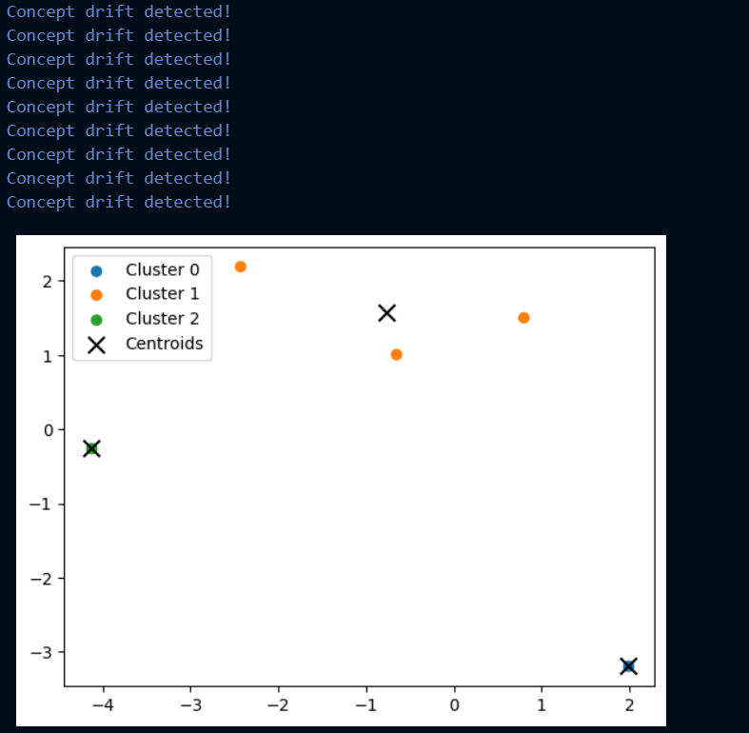
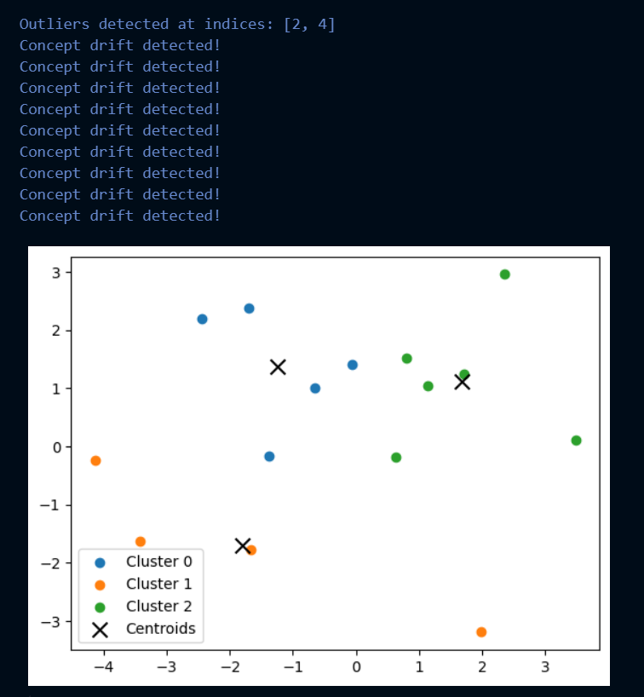
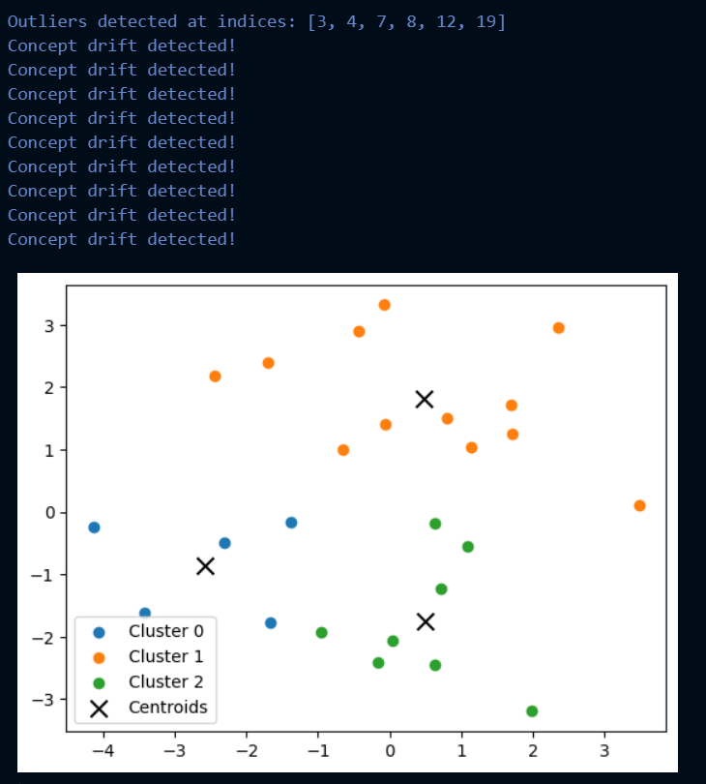

And so on…….

